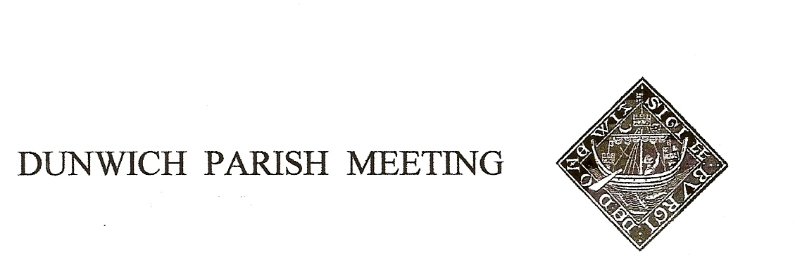Draft Minutes of Dunwich Parish Meeting Annual General Meeting held on
30th April 2021, held via Zoom under Coronavirus restrictions.
Meeting commenced at 7.30pm

- Welcome and apologies for absence:
Present:: R Smith (Chairman), G&A Abell, , D Boechler, C Brookhouse, J Cary, M Caws, D Cole, D&H Cook,
D Copnall, S&J Earp, J Godfrey, J Hamilton, S Malkin, H Morris, J Perry & S Taylor, J Sharp, S Strickland,
M Williams Visitors: N. Mayo,
Apologies:, L Beaumont, T Roberts, M Sheppard, R Sutton, M&J Whitby, B&M White, R Walter, J Zarins

- Election of Officers of the Parish Meeting. There had been 3 nominations, one for each of the current officers. Rod Smith had been proposed as Chairman by J Hamilton and seconded by C Palmer, Geoff Abell as Vice-Chair by David Cook and seconded by J Zarins, and Doug Boechler as Treasurer by S Goodwin and seconded by J Goodwin. The officers were declared re-elected.

- Minutes of the Parish Meeting held on 8th January 2021. The Minutes of the 8th January 2021 Parish Meeting were agreed by assent, with no objections, and they were duly signed by the Chairman.

- Matters arising from the minutes not otherwise on the agenda. None

- Treasurer’s Report. Present balance £2,819. Doug Boechler went through the Annual Accounts, starting with the Internal Audit Report, and thanks to John Cary for acting as Internal Auditor. The Annual Governance Statement is the Parish Meeting’s declaration that all appropriate financial controls are in place and risks have been assessed and addressed. Proposed for approval by G Abell, seconded by D Cook, and passed nem con. The Accounting Statements reflect the Meeting’s income and expenditure for the year to 31st March 2021; the most significant elements being the purchase of the traffic control system installed at the top of the village and its funding by a one-off doubling of the precept and generous grants from Dunwich Town Trust and the District Council. The accounts reported a deficit (anticipated) of £712 for the year, leaving accumulated funds of £1,801 at the year end. Approval of the Accounting statement was proposed by C Brookhouse, seconded by D Cook and passed nem con. Finally, as the Meeting’s Income and Expenditure are both below £25,000, we are entitled to declare the Meeting exempt from submitting the accounts for external auditing, but they must be displayed on notice boards and village website. Approval of the Certificate of Exemption was proposed by J Sharp, seconded by J Hamilton and passed nem con.

- Amenity Report

Traffic Calming: Chairman sought comment on effectiveness of speed control sign, now alternating between the Westleton and Blythburgh roads. General agreement that they are effective, and no evidence of driver fatigue, but concern that cars were now speeding as they leave Dunwich on the Westleton road. Agreed we would experiment with turning the control on its present post. S Earp suggested we might add a “Thanks for driving carefully through our village” message on the Dunwich signs at the entrances to the village. Concern expressed about increasing the amount of signage, in terms of distraction and diminishing returns. It was pointed out that
the present entrance signs carry the message to “Follow direction signs” which date back many years to an experimental one-way system and are now outdated and this could be an opportunity to replace them. Chairman will review options with Sharon Earp.
She also drew attention to the ‘Quiet Lanes’ initiative, a funded pilot scheme in Suffolk to encourage considerate driving; agreed we would register an interest and learn more about what it entails.

Telephone Box: Various options for future use had been suggested – book exchange, seed swap, info board, message board. J Cary had designed an internal framework for the box which would enable any or all the options to be realized, and was asked to go ahead with construction. Before installation, Chairman will call working parties to do repairs on the box. Initial budget of £250 agreed.

Use of box to house a defibrillator had been suggested, but location deemed unsuitable; both The Ship and the beach café had offered to house one. Town Trust are looking at options.

Dunwich Dynamo. Will take place on night of 24/25th July. No transport is being organized this year, so there will be fewer bikes than usual but more cars/vans to carry cyclists home and probably more pre-event overnight parking. Chairman will post on the event Facebook page and ask vehicles to use the beach or church car parks.
Permissive Path, Westleton Rd. Chairman had received a request for support from a member of the public in the establishment of a permissive footpath on RSPB land parallel to Westleton Road between the tracks to Mount Pleasant and Raceground Cottage. John Cary said the path was already established and in use, with the agreement of all parties. S-bend at top of village. This has always been dangerous, especially with the hedge on the left (when driving east) so overgrown. Ending of the lease on the corner field offers the opportunity to thin and lower the hedge, and Chairman had been trying to identify the owners. It appears to be a group of 4 people unknown to the village. It was suggested that either Richard Sutton or Sarah Donavan may know them and Chairman will pursue. No work can now be done until at least the end of July because of nesting birds. New posts on High Street. Concern was expressed about the erection of a line of posts on High Street, on public land, by the owner of the adjacent property without prior consultation or agreement with anyone else. The posts were considered a significant hazard to traffic turning in from the already-dangerous bend, a loss of long established parking access for the residents of Long Row and an inconvenience to the postman collecting from the adjacent box and to the mobile library. It was understood that the installer had now agreed to remove at least some of them but without commitment to time scale. It was the unanimous wish of the Meeting that the Chairman write to the owner of Friars Lodge to request removal of all the posts as soon as possible.
- Coastal Defence. Chairman reported that East Suffolk Council and the Environment Agency had been invited to the July meeting to report on the latest data on coastal erosion.
8 . Community Policing in Dunwich Forest Chairman had attended a meeting with police at which the longstanding issue of cruising in the lanes of Dunwich Forest was discussed. The police are fully aware of the issue and are taking action to deal with it.
- Reports from Village Organisations Reports from Dunwich Greyfriars, Dunwich Town Trust, the WI, St James PCC, Jubilee Committee, NT and RSPB had been circulated prior to the Meeting. Re the NT report, one member regretted the locking of the NT reserve at night. It was explained that it remained open for pedestrian and cycle access.
There had been no report from the Coffee4U group, who had not met this year due to the pandemic but were intending to restart in autumn 2021.

- AOB A Abell advised that although Sunday services had resumed the church was not allowed to open to tourists before May 17th.
John Cary proposed that mowing on the Millennium Green/ Triangle be reduced to encourage bees. Agreed.
Chairman said that when the Minutes were distributed there would also be a link to a government survey seeking views on the future legality of Parish Meeting by Zoom (which will become illegal after 1st May). He encouraged completion of the survey.

- Date of Next Meetings: Friday 23rd July 2021 and Friday 29th October.
There being no further business the Meeting closed at 8.55pm.

