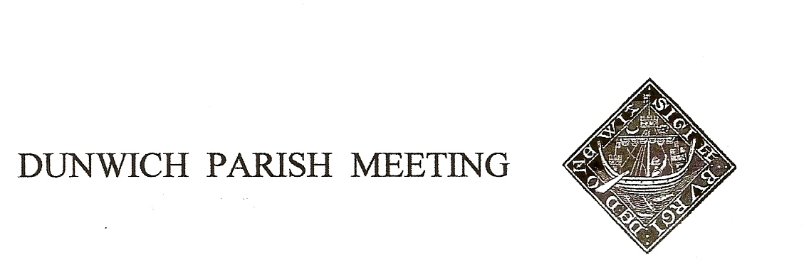
Draft Minutes of Dunwich Parish Meeting – the Annual Meeting - held on
29th July 2022, in Dunwich Reading Room, starting at 7.30pm.
1. Welcome and apologies for absence: Present: R Smith (Chairman), G&A Abell, C Blauth, D Boechler,
J Cary, D Cook, J Hamilton, S Hargreaves, C Palmer, J Sharp, R Walter, M&B White, M Williams,
Visitor: -
Apologies: L Beaumont, P Borel, C&K Brookhouse, H Cook, S&J Earp, J Godfrey, S&H Morris, M Palmer T Roberts, M Sheppard, S&A Strickland, C Weisser, J Zarins,

2. Minutes of the Parish Meeting held on 29th April 2022. Agreed, proposed J Sharp, seconded J Cary, passed nem con.

3. Matters arising from the Minutes not otherwise on the agenda. None

4. Succession Planning. Chairman reiterated that all three current officers would be retiring at the next AGM (April 2023) and encouraged some thought about succession. Anyone interested is invited to contact any of the officers to discuss the roles and requirements. The next regular session of the officers, to progress issues raised at the full Parish Meeting and to plan the next agenda, will be held on 27th August at 3.00 in the Reading Room, and anyone interested in becoming an officer is invited to attend.

5. Treasurer’s Report. Present balance £2,304.

6. Jubilee Committee. Chairman proposed that the formal thanks of the Parish Meeting should go to the committee – Sharon Earp, Helen Morris and Doug Boechler – and to all the volunteers who contributed to making the Jubilee celebrations very special.
The Committee has announced that for 2023 a BBQ and Barn Dance will be held on 24th June.

7. Planning. i) Sizewell C. As recently announced, the Planning Inspectorate had recommended against development of Sizewell C but been over-ruled by the Secretary of State. Chairman confirmed that the PI were most concerned about the availability of fresh water supplies to build and run the power station, and referred members to a recent Guardian article www.theguardian.com/commentisfree/2022/jul/27/nuclear-power-station-sizewell-c-water-suffolk. EdF still have to find investors, and may face judicial review of the Secretary of State’s decision. Chairman advised that the 2 organisations that had opposed Sizewell C had merged and were fundraising for further legal action.
ii) The Ship. Chairman referred to the letter, distributed on the circulation some weeks ago, from The Ship’s architect to the planners and suggested he should respond to the points raised by writing to the planners on behalf of the village, recommending the application go before a referral panel. Agreed. Further comments were made from the floor about garden lighting and its conflict with our Dark Skies initiative, music in the garden, and the mobile field kitchen’s fumes and cooking smells.

iii) Planning Consultation on Development in Countryside Clusters. The effects of the proposed policy were described, particularly how it appeared to prevent any new development between the upper and lower halves of the village. Agreed we should not make a village response to the consultation but individuals are invited to make their own if they wish.

8. Amenity Report
Jubilee Benches: Chairman thanked all involved in the successful installation of the new benches.
Quiet Lanes Initiative: Sharon Earp had reported that we are still waiting for County Council to install poles for signage. It was intended that the new poles would also carry existing signage to avoid a proliferation of poles.

Dark Skies: Promotion for the initiative will follow in the autumn. DashAstro have been invited to give a talk/demonstration.

Defibrillator: a new defibrillator had now been installed in a cabinet at The Ship car park. Chairman expressed thanks to Leiston First Responders and to Nicky Kinahan at Dunwich Town Trust for sourcing the kit, and to The Ship for paying for the cabinet and the power feed. Angela Abell had suggested that CPR training was now recommended to keep a victim’s heart going until the defibrillator arrives. Suffolk Accident Rescue Service offer such training and at was agreed we should arrange a session in the Reading Room. British Heart Foundation also has a short, online training package at www.bhf.org.uk/revivr

Pavement on St James Street: it was noted that there had been further instances of pedestrians tripping and falling on the pavement where there is a sudden change of levels; the drop is still not sufficient for the Highways Dept to take action. Chairman suggested that the time was coming when we should take action ourselves, perhaps filling that section with self-binding gravel which is inexpensive and effective. Defer to next meeting for a decision. The plastic grid section has lost its grass; it was agreed we should have one final attempt at reseeding this autumn, working party to be arranged.

Building debris from the Old Woodyard. It was noted with thanks that the soil and debris piles had been removed. Concern was voiced about the remaining bonfire heap as a fire risk in current conditions. Chairman will speak to the owner.

Water Bowser: John Earp had suggested that with the likelihood of more very hot summers and high fire risks from our being surrounded with forest and heathland, the village should consider buying a water bowser (a large towable water tank with petrol driven pump attached). This might help contain a fire until the Fire Brigade arrive. Geoff Abell said that The National Trust has one (1100 litre, delivering c50l/min), cost £4,500 - £5,000. All agreed this was an idea worth exploring, and that John Earp should be asked to develop it, noting that we would need to address issues of storage, maintenance, regular running of the engine/pump, manning and back up.

10. Any Other Business.

Dunwich Dynamo. Chairman considered that the event had worked well this year, but was concerned at the bottles and other debris left on the beach, as a result of which he had put a note on the Dynamo’s website. Chairman will liaise with the transport organisers prior to the next year’s event.

The Meeting was declared closed at 8.55. Next Meeting will be on 11th November 2022. Note change of planned date.

