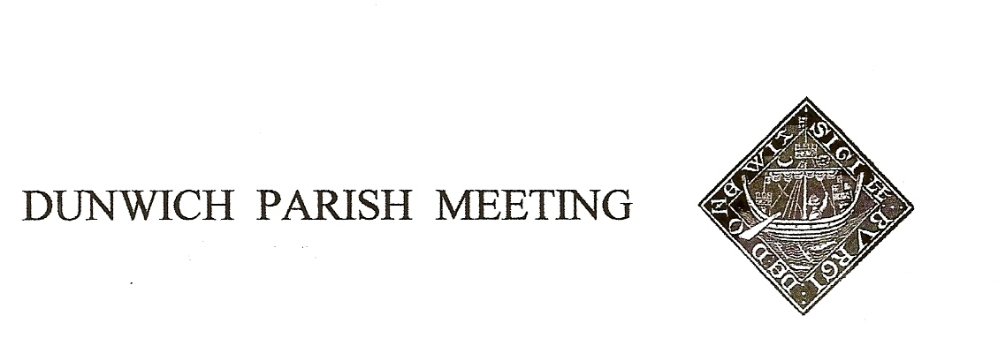
Draft Minutes of Dunwich Parish Meeting – the Annual Meeting - held on
29th April 2022, in Dunwich Reading Room, starting at 7.30pm.
1. Welcome and apologies for absence: Present: R Smith (Chairman), G&A Abell, E&C Blauth, D Boechler, C&K Brookhouse, D Copnall, J&S Earp, C Palmer, J Perry, J Sharp, S&A Strickland, R Sutton, C Weisser, B&M White
Visitor: N. Mayo (Dunwich Town Trust Chairman)
Apologies: L Beaumont, M Caws, J Cary, D&H Cook, J Godfrey, J Hamilton, K Kellaway & R Leanse, S&H Morris, M Palmer, T Roberts, M Sheppard, S Taylor, R Walter, M&J Whitby, G&M Williams J Zarins

2. Minutes of the Parish Meeting held on 28th January 2022. Angela Abell proposed an amendment to item 8 of the Draft Minutes to make it clear that the table tennis table was not the property of the Reading Room but its owner had kindly agreed it could be used by the village. With that amendment, the Minutes were agreed nem con and duly signed by the Chairman.

3. Matters arising from the Minutes not otherwise on the agenda. None

4. Election of Officers of the Parish Meeting.
Current Officers were proposed for re-election as follows:
As Chairman, Rod Smith was proposed by Jane Zarins, seconded by Helen Morris
As Vice Chairman, Geoff Abell was proposed by Jean Hurrell, seconded by David Cook
As Treasurer, Doug Boechler was proposed by Angela Abell, seconded by Simon Strickland
and, there being no objections, were declared elected. Each of them made it clear that this would be their final year of office, but would give every assistance to aid a smooth transition to a new team when the time comes.

5. Treasurer’s Report. Present balance £2,785. The Annual Accounts for the year to 31st March 2022 were presented to the Meeting. Activity during the year resulted in an annual deficit of £469, with reserves at the year end of £1,333. Principal items of expenditure had been £660 for the Jubilee Bench (funded to £500 by grant from the District Councillor’s locality fund) and £475 for refurbishment of the Dunwich Exchange. Various documents required formal approval;
i) Annual Governance Statement – proposed by Angela Abell, seconded by Judith Sharp
ii) Accounting Statements for 2021/20 - proposed by Chris Blauth, seconded by Julian Perry
iii) Certificate of Exemption - proposed by Simon Strickland, seconded by Christine Palmer.
All were passed nem con. John Cary was thanked for acting as Internal Auditor.

6. Reports from Dunwich organizations. Reports from DTT, WI, Dunwich Greyfriars Trust and the PCC were read to the Meeting and will be made available on the village website.

7. Planning. i) The Ship. There had been no decision by ESDC on the retrospective planning application for the garden; Chairman had written to the case officer but had no response. Simon Strickland suggested writing to our District Councillor in a bid to resolve this protracted matter.
ii) Sizewell C. Geoff Abell advised that the main bid by EdF to construct Sizewell C is currently with the national infrastructure planning inspectorate and their recommendation to the Secretary of State is due within the next 2 months. Dunwich has been invited to join with all the other local councils in signing a letter to the Secretary of State for BEIS in protest at what are viewed as his prejudicial actions, and financial support for the project when he is supposed to be an impartial judge of its merits. The draft letter had been circulated prior to the Meeting; Simon Strickland suggested that we suggest to the authors that the acronyms in it be expanded or a glossary provided. The Meeting authorized the Chairman to commit Dunwich’s signature to the letter.

8. Platinum Jubilee celebrations. Sharon Earp outlined the arrangements for the weekend. Anyone still without tickets for the Hog Roast is urged to contact Sharon within the next few days as numbers have to be confirmed to the caterers very shortly.

9. Amenity Report
Quiet Lanes Initiative: Sharon Earp reported that we are still waiting for County Council to install poles for signage.

Dark Skies: Promotion for the initiative will follow in the autumn, with encouragement to the village to turn down external lighting. It was suggested that we invite DashAstro to give a talk on the sky at night.

Siting of Jubilee Benches: concern was expressed about the proposed siting near the bend at the top of the village; a site on High Street had been offered by the owners and Gallows Field was suggested as an option. It was pointed out that the benches at the bottom of the village are also close to the road but are nonetheless very popular. Chairman will convene a site meeting with interested parties within the next week or so to finalise locations.

Table Tennis. The group meets on alternate Mondays, 5-7 in the Reading Room and has thus far proved very popular.

Building debris from the Old Woodyard. Simon Strickland commented upon the continuing piles of debris. Chris Brookhouse (owner of OW) advised that the builders are contractually required to remove and make good at the end of the project, which is expected in about 6 weeks.

10. Any Other Business.

Footpath on St James Street. Christine Palmer commented on the poor state of the footpath, the failure of the plastic webbing and the dangerous change of elevation in some parts, creating trip hazards. She recommended that no further attempt should be made to remedy the situation ourselves and that all the failed areas should be laid with tarmac. Chair advised that all this had been shown to Highways just a few months ago and whilst they recognised the problem it was not regarded as a priority and in its current condition they would not schedule it. Highways only regard pavements as dangerous if there is a hole/drop of 10cm – about the height of a brick.

Yoga. Katherine Brookhouse advised that Yoga classes had started in the Reading Room, Fridays 9.30-10.30.

The Meeting was declared closed at 8.50. Next Meeting will be on 29th July 2022.

