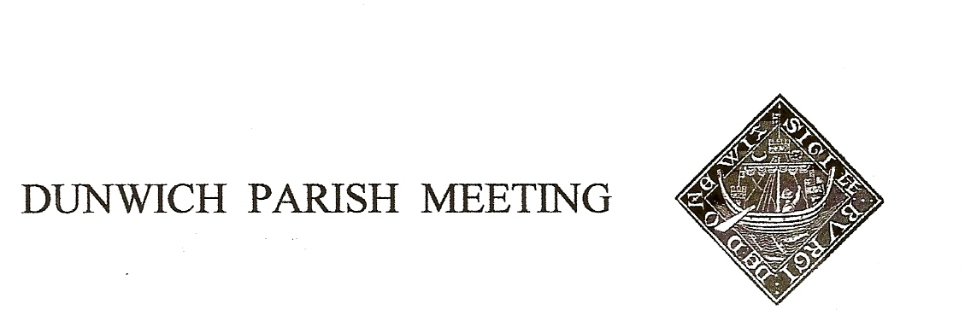
Draft Minutes of Dunwich Parish Meeting held on 28th July 2023 in Dunwich Reading Room starting at 7.30
- Welcome and apologies for absence:
Present: H. Morris (Chair), J. Sharp, J. Cary, A&G Abell, R. Bessell, D. Cook, J. Godfrey, J. Hamilton, S. Hargreaves, M. Holt, N&S Malkin, S. Morris, C. Palmer, R. Robinson, M. Sheppard, B&M White, J. Cox, T & M Beckham, S.Elsley, I. Macaulay
Visitors: Paul Ashton, East Suffolk Council, Katie Lockett
Apologies: L. Beaumont, C. Brookhouse, H. Cook, J&L Prior, T. Roberts, A&S Strickland, R. Walter, J. Zarins
- Minutes of the Parish Meeting held on 28th April 2023 Acceptance proposed by Geoff Abell seconded by Roderick Smith ; Agreed nem con.

- Matters arising from the Minutes not otherwise on the agenda
There were none.

- Treasurers Report:
Cheques paid out were: £100 for CPR training (agreed to go under amenity line); £48 x 2 to Ray Bater for mowing, £385 for insurance. Current balance is £3004.68. Barclays Bank are yet to update signatories.
- Planning
i The Ship: John Cary represented us at The Planning Committee putting our case and correcting inaccuracies. It was a close call (4 votes to 3) but permission was granted with some small concessions. The outside kitchen had its days restricted to 28. The Ship have said that they do not intend to use the outside kitchen at all as it doesn’t work for them. It is unclear whether this restriction applies to the outside bar. Helen Morris said she would investigate this. The outside lighting has to be switched off by 9.30 or sundown, whichever is later. Helen has liaised with The Ship and their gardener about planting in the garden for the future. Native hedging will be planted around the old entrance and existing hedging renovated. The Ship have said they are planning to move the refrigeration units into the garden at the back (with due care needed of the ancient fig and cherry trees) and will be hidden by screening. We do not have a time scale for this. Ray Bessell informed the Meeting that he had made a complaint about the board sign on the side of the refrigeration unit which would have required planning permission because of its size.

ii EDF/Sizewell C: Judith Sharp attended a meeting with Sizewell C on Zoom on Monday 10th July with Julia Pyke (Co-Leader Sizewell C and Marjorie Barnes. Lack of co-ordination with Scottish Power was raised and acknowledged. Mitigation in the form of new Marsh Harrier habitat was mentioned. Julia conceded that traffic would be very heavy at times during construction and that 600 lorry movements a day would occur and that disruption for locals would be considerable.
Sizewell C are keen to emphasise that there will be a mitigation fund once a development consent order is obtained and that they are interested in hearing proposals. You can visit them at their information office, 48-50 High Street Leiston IP16 4EW, without an appointment between 9.30 a.m. and 5 p.m. weekdays only. The office is closed from 12.30 - 1.30. You can call them FREEPHONE 0800 197 6102 weekdays 9-5 or write FREEPOST SZC (no stamp or further address required). General inquiries: info@sizewellc.com
A representative from Sizewell C will be at the next Parish Meeting to give a presentation and take questions.
Paul Ashton offered to attend any meetings we had if we would like him to.
iii National Grid: There have been no further developments. The Dunwich Town Trust received a map of potential scoping areas for cabling as they are owners of The Corporation Marshes which may be affected. Dunwich was not shown as a potential area for scoping.
iv Application for change of use of agricultural land adjoining Westleton Road: There are 25 comments on the planning portal, 24 of which are opposed. Amongst other consultees, Highways have said it is unsuitable; Historic England has a holding objection because of ancient buildings. It may be some time before a formal decision is given.
v Application for proposed agricultural implement store and formation of new vehicular access: There were 10 objections to this. Permission has been given for the new entrance by highways but on condition that the gate is set back 8 meters. We are waiting for a formal decision.
Helen Morris volunteered to speak with the owners about the hedge on the bend which needs to be kept cut back for visibility.
We have joined ESPA (East Suffolk Planning Alliance) who want the local parishes to be recognised as stakeholders.
Paul Ashton recognised that the planning process as it is is unsatisfactory for all parties.

- Amenity Report
i Potholes were filled before the Dunwich Dynamo. The flooding at the bridge is going to be pumped out, but this is a recurring issue. Pavements: Following two reported accidents, we had a meeting with Wayne, the community liaison engineer. They were only prepared to fill the gap with soil and it will be reseeded later in the year. Wayne stated that the hedges along the north side of the road needed to be kept back to the original line. Helen Morris obtained quotes from Council approved companies for replacing the verges and tarmac with the appropriate matching bonded tarmac. The most affordable came to £3,276 for the 25 metre stretch and £8,688 for the whole 100 meters. Geoff Abel proposed that the Meeting pursued funding for the entire stretch, seconded by Jill Cox with 13 votes in favour and 2 against.
Reporting tool cards were handed out www.highwaysreporting.suffolk.gov.uk What they really require is a photo. There is a tool for fly tipping and litter as well which is also very effective. We would encourage anyone who notices anything that needs attention to report it using the tool, only taking care not to duplicate requests as this creates problems for the council and skews their results.
ii Bulbs The offer of 1,500 free bulbs was so oversubscribed that this has been reduced to 500 daffodil bulbs which we will receive in October. A team of planters will be needed to plant them.
iii Coronation Bench following a suggestion that we marked the Coronation with an inscription on the new bench by the green at the top of the High Street it was clear that it would be cheaper to buy a new ready carved bench than have an inscription carved into the existing one. Angela Abell proposed that we bought a new bench and re-sited the other one in Gallows field. Roderick Smith seconded this and there were 10 votes in favour.
iv Dunwich Dynamo This passed off well and efficiently and caused minimum disturbance. Thanks to Henry Tomlinson for moving the bins onto the green. Next year we need to put cones out further down St James Street. We discussed putting up a sign to remind cyclists to keep quiet in the early hours as villagers are sleeping.
v Millenium Green verge parking this seems to have been a temporary problem and seems to have passed. We will keep an eye on it.
- Jubilee Committee: BBQ and Barn Dance Thanks to everyone who helped to make this event work so well. Many thanks to the Jubilee Committee for their hard work. There has been a suggestion that this event returns to its original time at the end of August. This is to be discussed with the Jubilee Committee.

- Any Other Business Anna and Ollie Curtis have agreed to look after the speed sign, many thanks to them. We discussed the siting of the speed sign and whether we could buy a bracket to make it easier to turn the sign round to face the other way as a better option than siting it by Bridge Cottage where it is difficult to see and of limited use as virtually no-one drives fast round that blind corner. A new bracket would cost £71.40 and we have this in the budget. It was noted that some people are still speeding through the village and that it would be a good thing if some formal speed observations were carried out as they are in other villages.
Jane Hamilton proposed that the Meeting pursued this, seconded by Simon Morris.
Geoff Abell informed us that the Greyfriars Trust was considering removing the fence that currently forms a barrier to the south side of the site. The Meeting was divided on the issue.
The Meeting was informed that there was a break in at Dunwich Heath and equipment stolen. We were reminded it was important to keep valuable equipment locked up securely.
The Dunwich Flower Festival will take place next weekend. Volunteers are still needed to welcome visitors to the church over the long weekend. We also need bakers to bring cakes for the cake stall. Jane Hamilton reminded us that there will be an Art Exhibition in the Reading Room running alongside the Festival.
The meeting closed at 9.10pm. The next meeting will be on Friday 27th October

