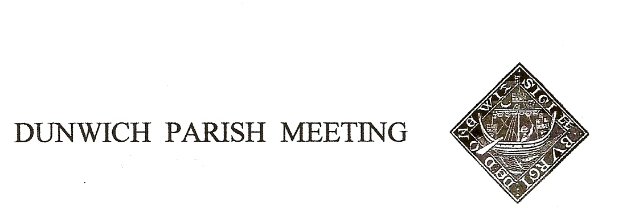
Draft Minutes of Dunwich Parish Meeting held on
28th April 2023, in Dunwich Reading Room, starting at 7.30pm.
- Welcome and apologies for absence:
Present: R Smith (Chairman), G&A Abell, C&E Blauth, D Boechler, J Cary, D Cook, J Earp, J Godfrey,
J Hamilton, D Hyatt, N&S Malkin, H&S Morris, C&M Palmer, J Perry, G Schacke Andersen, K Schlatte,
J Sharp, S Strickland, S Taylor, M&B White, M Williams;
Visitor: H Curtis & 1 other
Apologies: L Beaumont, C&K Brookhouse, E Bidwell, M Caws, H Cook, M Flannery, T Roberts,
M Sheppard, A Strickland, R Walter, G Williams, J Zarins,

2. Minutes of the Parish Meeting held on 27th January 2023. Acceptance proposed by Angela Abell, seconded by Julian Perry; Agreed, nem con.

- Matters arising from the Minutes not otherwise on the agenda.
- Mick Palmer raised the matter of the dangerous pavement on St James St. After some discussion and on a proposal by Angela Abell, seconded by Helen Morris, it was agreed that the currently gridded section be left for this season to see if recent reseeding succeeds, but that the very dangerous unimproved section be filled with a mix of MoT and shingle. The issue of liability needs to be checked first.
- John Cary proposed, Debra Hyatt seconded, that Millennium Green should have a ‘No Mow May’. Agreed by a large majority.

4. Election of Officers for 2023/24. The following nominations have been received:
Office | Nominee | Proposer | Seconder
Chair | Helen Morris | Mick Palmer | Christine Palmer
Vice Chair | Judith Sharp | Rod Smith | Jane Zarins
Treasurer | John Cary | Jane Hamilton | Judith Sharp
There being no other nominations all three candidates were declared elected.

5. Treasurer’s Report and Annual Accounts. Present balance £1,589. Geoff Abell took the Meeting through the annual accounting returns, copies of which will be posted on the lower notice board and the village website. The Meeting thanked John Cary for the Internal Audit Report. The following documents were shown and approved unanimously by the Meeting:
Document | Proposer | Seconder
Annual Governance Statement | Judith Sharp | Maureen White
Accounting Statements 2022/23 | Judith Sharp | Sally Taylor
Certificate of Exemption | Chris Blauth | Joan Godfrey

6. Reports from local organisations. Representatives of Dunwich Town Trust, St James PCC, Dunwich WI, Dunwich Greyfriars Trust, Jubilee Committee, Coffee4U, Dunwich Reading Room & Museum Charity (now Dunwich Community Heritage Centre), and Table Tennis group provided brief verbal reports to the Meeting on their year’s activities. Copies of these reports will be posted on the village website.

7. Planning. i) The Ship. The Chairman advised that the long outstanding application had now been referred to the Planning Committee, thought to be on 13th June, for decision, following pressure from Councilor Brooks.
John Cary pointed out that we could send a representative to speak at the meeting.
ii) EdF. Rod Smith reported on his meeting with Michelle Emerson Grey of EdF regarding mitigation. EdF will put £25m into the Suffolk Community Fund, to be bid for only when EdF have all their permits and spades have gone into the ground. Separately, all communities will have a liaison person appointed; the Pretty Road route out of Theberton will be closed when the bypass is built but an alternative connection will be provided; and EdF claim that light pollution will be lower than at Hinckley.
iii) National Grid. The Eurolink project is now renamed Lionlink, and there are suggestions from NG of better co-ordination with other projects to reduce onshore infrastructure. We wait to see if this has any impact on their proposals for Dunwich.
iv) Application for Change of Use of Agricultural Land adjoining Westleton Road. A letter from the West family (owners of the land) was read to the Meeting; the implied threat therein of the alternative to the glamping scheme being pig farming was widely condemned and not taken seriously, being destructive of the West’s existing assets. Various specific points were made:
- Zen, the operators, are a brand new company with no experience and no capital
- The small operation will not be economic and will lead to expansion to make it pay, a view supported by Zen’s own plot outline for the site which covers twice the area shown in the current application
- The claimed 2.5 ft new jobs is unsupported
- The village had made no objection to the West’s current redevelopment of their barns to new holiday accommodation because that was an acceptable project in keeping with the village, by contrast to the new proposal.
- Parking arrangements are wholly impractical – no camper will willingly haul their luggage by hand up a 300m track to the caravan
- The Dunwich road infrastructure, incl the disgraceful condition of St James Street, will not support additional traffic
- Light pollution from the vans, atop the hill, is not consistent with Dunwich Dark Skies policy.
- There had already been many personal objections to the application, covering a range of issues.
On a show of hands the Meeting unanimously opposed the development, and Rod Smith proposed, Libby Blauth seconded, that “This Parish Meeting should write to Planning to express the Meeting’s objections to the proposed development”

8. Amenity Report
i) Bulbs Offer. Chairman reported he had accepted an offer to supply 1500 free narcissi/daffodil bulbs for planting on verges round the village. Working parties for planting to be organised in the autumn.
iii) Defibrillator Training: Chairman reported on a successful training session on 16th April run by Heart 2 Heart, attended by 13.The access code for the machine at The Ship carpark is C159X. The session taught CPR technique in addition to use of the defibrillator. £100 had been donated to H2H.

9. Any Other Business.

i) Maureen White again raised the issue of drainage on the Sbend at the top of the village, speeding there and risk to pedestrians. Dave Cole thought the solution to the drainage issue would be to connect a drain there to the adjacent sewerage pipe, which was always short of flowing water. Chairman agreed to write (again) to Highways whose responsibility it all is.

ii) Advance warning of the Dunwich Dynamo on the night of 1st/2nd July

There followed a short presentation to the Chairman and the other outgoing officers, and the Chair-ship was formally handed over to Helen Morris.

The Meeting was declared closed at 9.35. The next Meeting will be on 28th July 2023.

