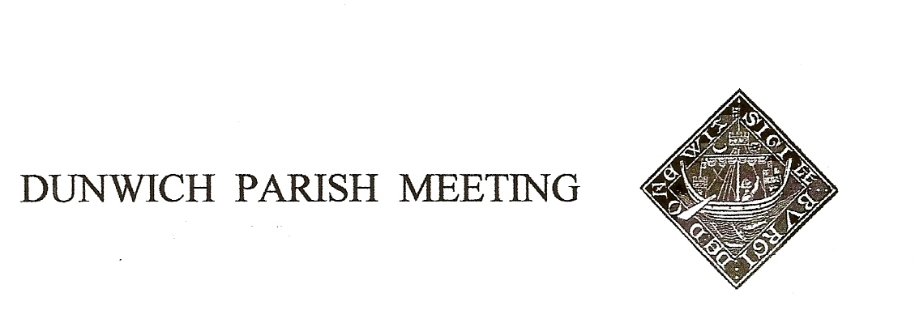
Draft Minutes of Dunwich Parish Meeting held on 27th October 2023
in Dunwich Reading Room starting at 7.30
- Welcome and apologies for absence:
Present: H. Morris (Chair), J. Cary, G.& A. Abell, R. Bessell, C. Blauth, C.& K. Brookhouse, D. Cole, D.& H. Cook, D.&J. Cox, J. Godfrey, J. Hamilton, E. Haxby, M. Holt, N. Malkin, S. Morris, R. Walter, M. Williams.
Visitors: Cllr. Paul Ashton (East Suffolk Council), A.&S. Buckley, K.&E. Lockett
Apologies: L. Beaumont, J.&S. Earp, D. Hyatt, S. Malkin, M.&C. Palmer, T. Roberts, R. Robinson, J. Sharp, R. Smith, B.&M. White, G Williams, J. Zarins
2. Sizewell C Community Liaison Team presentation:
Michelle Emmerson and Richard Knight of EdF explained the Deed of Obligation, a legal agreement signed by East Suffolk Council, Suffolk County Council and NNB Generation Co. (SZC) which specifies the responsibilities of Sizewell to the community and commits to funding. It incorporates 12 community pledges which aim to minimise disruption to the community.
Workers: . Seven years into construction the number of workers would peak at 8,000, one third from East Anglia. The accommodation campus would house 2,400 with an additional 400 caravan pitches. On site occupational health would be provided and all workers would sign a Code of Conduct agreement.
Community Fund: £23m would be available once construction has started for projects which promote the economic, social or environmental wellbeing of Suffolk, with an additional neighbourhood fund for grants of up to £750.
Light mitigation: all site lighting would be LED based which would minimise light spill.
Transport: a new section of the A12 would by pass Farnham and Stratford St Andrew and a new Sizewell Link Road from the A12 south of Yoxford would be built, both permanent. Temporary Park and Rides would be provided at Wickham Market and Darsham. Sixty percent of freight would be transported by rail or sea. The rail link to Leiston would be upgraded and, to monitor and address traffic flow, a freight management facility for HGVs provided at the A12/A14 junction. A high level jetty, which would not affect beach access, would be provided for materials arriving by sea.
Questions from the floor: covered local employment and training opportunities, whether sufficient accommodation was being provided, the regulation of the mitigation
works, dialogue with local health and education providers, ensuring an adequate water supply with a temporary desalinization plant and the time-line. Pre-commencement work had already begun; the main work was awaiting the final investment decision and final Development Consent Order; expected to start in 2024, during this parliament.
Detailed information is available on the Sizewell C website and at www.SZCworkstracker.co.uk. The drop in Sizewell C shop on Leiston High Street is open Monday to Friday 9.30 to 5pm. Once received, the presentation slides will be posted on the DPM website.
3. Minutes of the Parish Meeting held on 28th July 2023:
Accepted and agreed nem con.
4. Matters arising from the Minutes not otherwise on the agenda: None.
5. Treasurers Report:
Current balance: £2,222.28. The expected year end income and expenditure were £2,660 and £2,036 respectively. A grant of £660 had been received from DTT for the purchase of the Coronation Bench, on which a discount saved £26. G. Abell proposed and E. Haxby seconded the authorisation of payment for the bench and the purchase of daffodil bulbs with the residual £26.
6. Dunwich Museum Funding:
J Hamilton advised that the museum had been awarded a grant from the National Lottery Heritage Fund. This would support The Way Forward, a 15 month project to share and develop plans for developing the Reading Room and launching a membership programme for the newly formed Dunwich Community Heritage Centre. The Chronicles partnership workshops would continue and an Activity Programme would engage the community with the work of the museum.
7. Planning:
i) Energy Projects:.
Sizewell C :– see above report.
Sea Link: a National Grid high voltage link to export excess power from Suffolk to Kent. Statutory Consultation – 24th October to 18th December. The current plan is for a 26 m high converter station to be built near Saxmundham. Ideally it was felt that this should go to a brown site such as Bradwell. All were encouraged to book onto a webinar on Tuesday 31st October; or to a drop in event at Aldeburgh 8th/9th November or Saxmundham, Market Hall, 24th/25th November.
Lion Link: an electricity link to connect off-shore wind between the UK and the Netherlands. The preferred landfall was now at Walberswick, Dunwich has been removed from the options to protect its offshore heritage. This is still a non statutory consultation but all were encouraged to get involved. Cllr Paul Ashton advised that the Council would be producing information and he commented that if one was rejecting the current proposal it was important to suggest an alternative option, there was no need to use the response questionnaires as all responses must be considered. He gave the Council’s position: that they had committed to make the best of Sizewell C if it went ahead, that offshore farms needed to coordinate with each other and with Sizewell, and that power should only come onshore to a brown field site.
ii). The Ship Garden: by 1st November the refrigeration units would be removed and the planting and hedging attended to. More compact refrigeration units would be sited in the garden. From 12th December to 2nd January a Christmas tepee in the garden would provide an extra bar facility – The Ship were to check that planning permission was not required for this temporary structure.
iii) East Suffolk Planning updates: none.
8. Amenity Report:
i St James Street: Mike Sheppard was thanked for cutting back his hedge. The earth fill along the verge had compacted well. An application for a grant to replace the verges with bonded tarmac would be made as soon as the Sizewell mitigation fund became available.
ii Bulbs: the 500 daffodil bulbs had arrived. H. Morris would place windmills to indicate where she intended to plant them and asked that individuals let her know if any of areas were not acceptable. She had acquired 2 bulb planters which fit onto battery operated drills and asked for volunteers to help with the planting.
iii Coronation Bench: ordered (see above).
iv. Speed sign: O.&A. Curtis were thanked for fixing the bracket, charging the battery and alternating the direction of the sign.
v Formal speed observations: currently waiting to hear from the police who could train people to become speed observers.
vi Break ins/police/CCTV: the police had been asked to drive round Dunwich more frequently. To help police track the movements of suspects H. Morris wondered if those with CCTV would be willing to let her know, on a confidential basis, that they have this facility. J. Cary explained that the museum does not have CCTV outside to protect the privacy of visitors, but as the meeting thought an outside camera there would be helpful he would take this forward.
vii One way signs: the redundant phrase ‘Please Follow Direction Signs’ still on the ‘Dunwich’ village entry signs could be peeled off which the meeting agreed should be done.
9. Dunwich Forestry Project:
This winter Natural England would be clearing the two stands on the south side of the Blythburgh Road, which were felled several years ago, to restore them to heathland.
10. Jubilee Committee:
The next Village Fun Day would be on Saturday 29th June. A get together to brainstorm the event was planned for December (date to be advised).
11. AOB:
King Charles III England Coastal Path: the route north out of Dunwich for the new Coastal Path, approved by the Secretary of State, will go west along St James Street and then up the Dingle track. To avoid walkers having to negotiate the blind double bend a new public footpath will be established along the south and west sides of the church car park to cross the Dunwich River over a new concrete bridge. SCC is tasked with establishing the trail on the ground with the work paid for by Natural England. Vegetation clearance along the proposed route prior to the construction work will start in November.
Next meeting: Friday January 26th 2024.
The meeting closed at 9.10pm.

