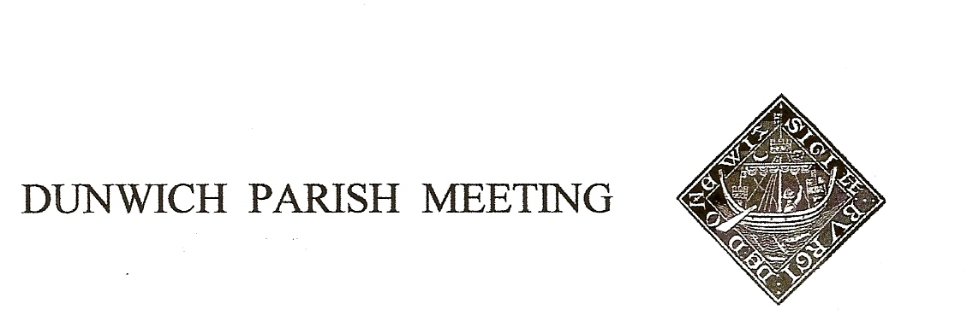
Draft Minutes of Dunwich Parish Meeting held on
27th January 2023, in Dunwich Reading Room, starting at 7.30pm.
- Welcome and apologies for absence:
Present: R Smith (Chairman), G&A Abell, C Blauth, D Boechler, C Brookhouse, J Cary, J Hamilton, S Hargreaves, H Morris, J Perry, S Taylor, M Sheppard, A&S Strickland;
Visitor: Paul Ashton (LibDem candidate for District Council elections in May)
Apologies: S Alderman, E Blauth, M Caws, D&H Cook, S&J Earp, C&M Palmer, H&M Tomlinson, R Walter, M&G Williams, A&D Worth M&B, White J Zarins,

2. Minutes of the Parish Meeting held on 11th November 2022. Agreed, nem con.

3. Matters arising from the Minutes not otherwise on the agenda. None

4. National Grid Eurolink Project. Rod Smith reported on discussions with other affected parish councils; in the absence of full consensus, each council had submitted its own response to National Grid’s consultation, all in objection. Our own submission had been copied to Therese Coffey MP and Richard Smith, County Councillor, both of whom had responded in support.
Rod said the emphasis was moving towards objection to the principal sub station planned for Friston, for completion of that will attract numerous connections with offshore generators and interconnectors to fill the surplus capacity scheduled for Friston. He referred people to the SEAS website for more information. (Home - Suffolk Energy Action Solutions

5. Succession Planning. The Chairman reiterated that all three current officers would be retiring at the next AGM (28th April 2023). Nomination forms have to be submitted to the Chairman two weeks in advance of the Meeting and are available from the Chairman or Vice Chairman; they will also be posted on the village website for downloading (dunwichpm.onesuffolk.net - look on the Minutes and Accounts page).

6. Treasurer’s Report. Present balance £1,979. A proposed budget for 2023/24 was circulated, including a £400 allowance for an as yet unspecified amenity project, and a proposed Precept of £2,000. Acceptance was proposed by Jane Hamilton, seconded by Simon Strickland and passed nem con.

7. Jubilee Committee. Helen Morris said that the next Winter Supper, on 7th February was sold out, but negotiations were underway with The Ship for another on 8th March, which The Ship themselves were keen to run. Simon Strickland asked whether it was proposed to mark the coronation in May with any event; Helen Morris responded that given the planned BBQ and Barn Dance on 24th June there were not the resources to manage a May event as well, it was suggested that the June one might have a Coronation theme.

8. Planning. i) The Ship. The Chairman advised there had been no further developments since previous meeting, despite his having written to the planning officer for an update. After some discussion it was agreed he should now write to our District Councillor to progress this.

ii) Sizewell C mitigation. EdF’s publicity suggests they have set aside £23m for mitigation of the impact of Sizewell C on local communities, but it is not clear how this can be accessed. The Chairman suggested that villagers develop a wish-list of projects, to be discussed at the next Meeting in April and in the meanwhile he will open dialogue with the new Director of Communications, Tom McGarry having moved on (to National Grid!)

9. Amenity Report
Defibrillator Training: The Chairman reported that volunteers from SARS (Suffolk Accident & Rescue Service) to lead the training on the defibrillator and resuscitation had not been forthcoming as intended. He would now approach St John Ambulance to see if they could offer similar. In response to a query at the last Meeting, he confirmed the defibrillator was fully registered with the emergency authorities , and was monitored and maintained by The Ship.
Dark Skies: John Cary noted that Darsham publicised their Dark Skies status with signs at the entrance to the village and suggested we do the same. Others thought the existing notices on the Boards were sufficient. Discussion was deferred to a future Meeting.
Anti- Eurolink Sign: Helen Morris, seconded by Angela Abell, proposed that the large sign installed opposite the Museum be removed and put in storage in case of future need. On a vote this was passed by 8 to 0 with 4 abstentions.

Pavement on St James Street: the reseeding experiment on a short section of the grid in the autumn appears to have succeeded. Geoff Abell said a working party would be called in late February/early March to prepare and reseed the rest of the grid.

Millennium Green (beside the church). John Cary expressed concern that cars were parking on the Green, degrading it, and suggested posts or logs be laid to discourage the practice; others thought it was not a significant problem and that barriers would disrupt mowing. The legality of such action was questioned.

The Chairman invited villagers generate ideas for discussion at the next Meeting.

10. Any Other Business.

Electronic Speed Sign. The Chairman reported this had broken, but was under warranty and would be returned to the manufacturer.

A volunteer was needed to take on the fortnightly exchange and recharging of the battery – anyone willing to take on this undemanding role should contact the Chairman please.

Road Closures. It was noted that the Westleton Road had been closed for three days this week without any advance notice being given. It was agreed we should write to Highways to protest about the lack of notice.
Road Safety in Dunwich. The issue of speeding at the S-bend at the top of the village was again raised. Sarah Hargreaves said the situation was particularly dangerous as cars were often parked between the end of her drive and the corner, making her exit hazardous. Geoff Abell said that Highways had been approached many times about a 20mph limit there but had always resisted. Paul Ashton was invited to speak at this point. He said that Highways’ criteria for designating 20mph zones was very restrictive, but that he had started a petition to SCC (which with enough signatures would force a debate) to enable parishes to have much more say in where their own 20mph zones should be. The petition can be found at https://paulashton.focusteam.org.uk/
Power Cut 9th February. The Meeting was reminded that Power Networks have given notice of a power cut to happen on 9th February between 9am and 3pm.

The Meeting was declared closed at 9.05. The next Meeting (the AGM) will be on 28th April 2023.

