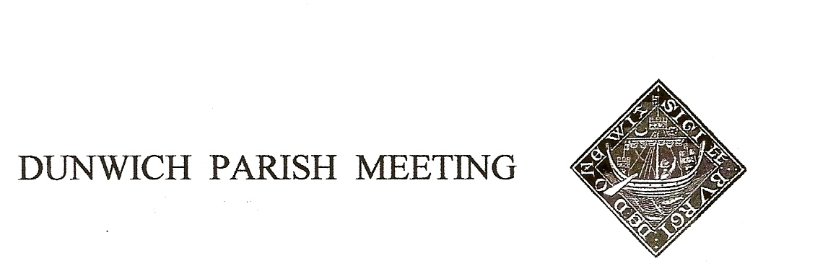Draft Minutes of Dunwich Parish Meeting AGM held on 24th July 2020, held in the Reading Room Garden under Coronavirus restrictions.

Meeting commenced at 6.30pm

- Welcome and apologies for absence:
Present: Dunwich Electors: R Smith (Chairman), G&A Abell, D Bakker, N Barham, R Bessell, D Boechler, J Cary, D Cook, C Elsley, J Godfrey, J Hamilton, M Holt, E Lewis Cracknell, C Palmer, J Sharp, S Strickland, R Walter, B&M White, J Zarins
Dunwich Non-Electors: C&E Blauth, C&B Brookhouse,
Visitors: N. Mayo,
Apologies:, A&S Barham, R Curtis, K Riches, H Cook, V Donovan, M Palmer, A Strickland, M Whitby

- Minutes of the Parish Meeting held on 10th January 2020.
Acceptance of the Minutes of the 10th January 2020 Parish Meeting was proposed by J Cary, seconded by A Abell, and they were duly signed by the Chairman.

- Matters arising from the minutes not otherwise on the agenda.
- Re item 7 (Beach Defence), chairman advised that the proposed attendance of Paul Patterson (District Council) and Gary Watson (Environment Agency) had been deferred until we can have a ’normal’ meeting.
- Re Item 5v) (National Trust Parking), GA clarified that NT parking, whilst free to Dunwich residents, still required pre-booking in line with NT’s current Covid-19 rules.

- Election of Officers of the Parish Meeting. There had been 3 nominations, one for each of the current officers. Rod Smith had been proposed as Chairman by Christine Palmerand seconded by Jane Hamilton, Geoff Abell had been proposed as Vice-Chair by David Cook and seconded by Christine Palmer, and Doug Boechler had been proposed as Treasurer by Heather Cook and seconded by Angela Abell. There being no other nominations the officers were declared re-elected.

- Election of DTT Trustee. There being no nominations for the vacant post there was no election.

- Treasurer’s Report. Present balance £4,102, pending the writing of a large cheque for the new traffic calming sign. Cqs requiring approval: DPM’s annual insurance £165.67, 4x£48 for grass cutting, £30 for admin expenses, £37.86 SALC subscription, £26.43 padlock and security for the traffic sign. Also a few items from the end of last financial year: £40 for Information Commission registration, £9.91 for grass seed, £40 for website hosting and £30 to Royal British Legion for poppy wreath. All proposed for agreement by Joan Godfrey, seconded by Nigel Barham, passed nem con.
John Cary proposed and David Cook seconded a motion that all itemized expenditure agreed in the annual budget should be paid without further reference to the Meeting; passed nem con.
Treasurer then turned to the Annual Accounts, copies of which had been circulated before the Meeting. Both the Annual Governance Statement and the Accounting Statement were proposed for approval by Angela Abell, seconded by Jane Hamilton, and passed nem con.

.
- Amenity Report
- Traffic Calming. Chairman announced the installation earlier in the week of the new sign at the top of the village, already tested by several at the Meeting. Total cost was in the region of £3,800, funded by grants from Dunwich Town Trust (£1,200) and Cllr Norman Brooks (£800) – thanks were expressed to both. The balance of the cost comes from DPM’s own resources.
- Telephone Box. BT had advised the Meeting that telephone service was being withdrawn, and the box itself had been accepted for the village, as agreed at the previous meeting, for a capital payment of £1. Chairman invited proposals for its use.

- Sizewell C and ‘Energy Coast’ infrastructure
Chairman explained that EdF’s application for a Development Consent Order (DCO) was now with the Planning Inspectorate (PINS) and all villagers should have received details of the EdF’s tour bus schedule where the DCO may be inspected. He encouraged villagers to sign up as ‘interested parties’ to the DCO process and would issue details of links to relevant web sites. Geoff Abell advised that at village level, councils were increasingly working in groups, in part to comprehend and process the technical complexities of the DCO and also to make a stronger combined representation, the latest letter to the Secretary of State signed by 58 local councils being an example. Simon Strickland asked whether there was advantage in inviting EdF or PINS to address the Meeting; Chairman thought EdF’s position is already well known and the PINS do not do public meetings. Maureen White suggested asking RSPB to expand on their concerns for us.

- Planning
There had been 3 applications since the last Meeting, at Dingle Barns, Middlegate Barn and The Old Woodyard, all still awaiting decision. Chris Brookhouse, the new owner of The Old Woodyard said a few words to introduce himself and his family.

- Any Other Business
- The new owners of Little Greyfriars had written asking if any grazing was available in the village. Any suggestions to the Chairman please.
- Geoff Abell asked if anyone had any information about the recently dead Barn Owl found near the box in Gallows Field. Brian White said that someone (unknown) had been using a rifle in the adjacent field a couple of weeks previously and he thought had killed a Kestrel. Shooting of all birds of prey is a criminal offence and should be reported immediately.
- Concern was expressed at recent speeding along St James Street (thought to be staff from The Ship). Chairman would talk to the management.
- The number of camper vans currently using the Beach car park was noted. Chairman said this is Town Trust land and the café has an interest in the situation too; it is for them to find a solution, but it may be the current use of the car park is a short term phenomenon linked to the post – covid relaxation of restrictions.

- Date of Next Meeting: Friday 9th October 2020.
There being no further business the Meeting closed at 7.30pm.

Annual Reports from village organisations, which normally are received at the Parish Meeting AGM, had been circulated prior to the Meeting.

