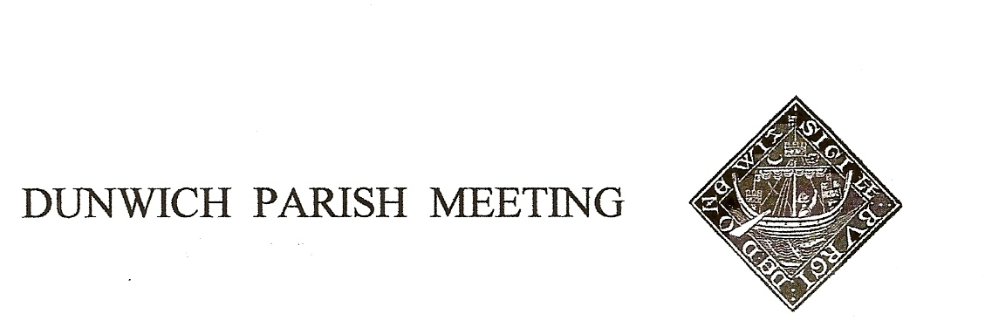Draft Minutes of Dunwich Parish Meeting held on 10th January 2020

- Welcome and apologies for absence:
Present: Dunwich Electors: R Smith (Chairman), G&A Abell, N Barham, D Boechler, D&H Cook, J Hamilton, E McCormick, K Maunder, M Palmer, J Sharp, K Riches, M Sheppard, M Williams
Dunwich Non-Electors: C Blauth, D Cole, S Hargreaves, J Perry, S Taylor
Visitors: N. Mayo,
Apologies: R Bessell, J Cary, R Curtis, J Godfrey, M Holt, C Palmer, S Strickland, G Williams, R Walter, B&M White, J Zarins

- Minutes of the Parish Meeting held on 16th August 2020. Minutes of the 16th August 2019 Parish Meeting were accepted; proposed by Angela Abell, seconded by Jane Hamilton, and duly signed by the Chairman.

- Matters arising from the minutes not otherwise on the agenda. None.

- Election of DTT Trustee. There having been no nominations for the vacant post there was no election. Chairman advised that the vacancy would be carried forward to the next Meeting. Mick Palmer said all members should do all they could to encourage younger members of the community to involve themselves in the various organizations of the village.

- Treasurer’s Report. Present balance £2,561.
Treasurer introduced the annual Risk Assessment. Agreed nem con.
Treasurer then introduced annual budget and precept decision. Projection for the current year (ending 31st March) is for a surplus of £164 in the year leading to an accumulated surplus of £2,542. The proposed budget for next financial year is very similar, with one major exception. It was put to the Meeting that, in the absence of the County Highways
offering any proposals for traffic calming at a cost below £10,000, the Meeting should itself purchase a permanent flashing speed sign for the top of the village. Chairman had researched the options and believed a battery-operated sign could be bought for between £2,500 and £4,000; independent research suggested the signs were very effective in slowing traffic. M Palmer said he was skeptical about their effectiveness and did not believe such expenditure was value for money. Doug Boechler responded that, living at the top of the village as he did, the speed of some of the traffic past his house, well within the 30mph zone, was considerable and we owed it not only to the villagers but to unsuspecting visitors to take measures to control the speed of traffic. He also mentioned that many of the speeders are connected to the village, both residents and employees. It was proposed by Judith Sharp, seconded by Katharine Riches that the Meeting goes ahead with the purchase, cost and details to be agreed in due course. This was carried with one dissenter.
Discussion then turned to the funding. The balance of the cost of the sign would be sought from other bodies, probably the Town Trust, but £2,000 would be met from the Meeting’s own resources. If there was no increase in precept (currently £1,000) and £2,000 is spent as above then reserves by the end of next year would be just below £1,000. This was considered too low, and it was proposed (Angela Abell) and seconded (Jane Hamilton) that we adopt a budget in which the precept is doubled, from £1,000 to £2,000 for one year only. The impact on villagers’ Council Tax bills will be to increase them by £16 (on a Band F property). Chairman said that in the event of the money not being spent on the proposed sign, for whatever reason, then we would operate the following year with a Nil precept. The proposal was carried with one dissenter.
- Amenity Report
- Dog Waste Bin. There was one fallen apart at the beach. Chairman said it had been reported to Norse who had accepted responsibility for its replacement, but so far nothing had been done. ACTION: Chairman will chase.
- Telephone Box. BT have now advised that, following Chairman’s writing to object to its proposed closure as reported at the last meeting, the box would remain in operation.
- Notice Board at the top of the village had been successfully repaired. Ray Bater was thanked for the work.
- Himalayan Balsam on Leet Hill had been cleared and burnt. The barns at Church Farm are being renovated using a local carpenter; owners had advised that no decision had been made on future use of the Church Farm land. [Added by Chairman post-Meeting]
- National Trust parking. Free parking at Dunwich Heath was still available for Dunwich residents. Those wishing to use the facility should take, as evidence, a Council Tax bill for their Dunwich property to the Information Hut on site where they would be given a special card that would entitle them to free parking for the rest of the year.
- Dunwich Forest car park nearest the village remains closed. Forestry Commission would complete their logging in the area in the next few months and reopen the car park by midsummer.
- Sex traffic in Dunwich Forest. Residents around St Helena had noted an increase in cruising and apparent prostitution along the Blythburgh Road. Chairman said that when he had taken it up with the Police they responded that no crime had been committed and there was no action they could take. Activity that was considered offensive by a witness would be considered a crime; if such activity were reported to the Police they might take action, but evidence would be required and no one should put themselves at risk in gathering evidence.
- Increase in petty theft. A small number of instances of minor theft from gardens and outhouses had been reported recently. Residents were advised to lock away anything of value.

- Beach Defence. Chairman reported that it had been almost 2 years since Paul Patterson (District Council) and Gary Watson (Environment Agency) last reported on the state of our beach. Paul has agreed to attend our July Parish Meeting and the Chairman will invite the Environment Agency to send someone to update us with the latest LIDAR data on erosion (or accretion) of shingle.

- Planning. The Planning Department at District Council would shortly go paperless, meaning that plans would no longer be available for viewing in a public place in the village, the only way of seeing them would be over the internet on the Council website (easy link to be provided). Chairman may have enhanced access (yet to be tested with a real application) and would be willing to let others view that if required.
Sizewell and the ‘Energy Coast’. Geoff Abell and the Chairman updated the Meeting. All consultation stages for Sizewell C had now been completed. EdF’s next step would be to complete a Development Consent Order application to the Secretary of State, in effect a planning application. Councils and the public would have an opportunity to comment, though not on the substance of the DCO only the quality of the public consultation so far. DCOs for the wind farm substation project at Friston have already been submitted by Scottish Power. GA said that one major area of concern is that traffic projections for each project had been made independent of the existence of other contemporaneous projects in the area – no one appeared to be looking at the cumulative picture.
- War Memorial. A visitor (Mr Jay) at the commemoration in November asked why his relative, Gunner Evans whose home was on St James Street, was not listed on the Memorial. He is buried in the graveyard in a Commonwealth War Graves Commission grave, having died whilst serving in 1944. Angela Abell had researched the options; Gunner Evans is ‘qualified’ to be listed on the memorial. The present lettering is in raised lead, the nearest contractor who can do matching work is in Northampton. It was agreed there is no objection to his name being added but the family would be expected to bear the cost. ACTION: AA to progress

- Any Other Business
- There will be a show – ‘Ancestors’ – in the Reading Room on 26 January, 4pm. Details to be circulated.
- Robert and Jason from The Ship and a colleague from The Crown attended the end of the Meeting, expressed the management’s wish that The Ship be more integrated with village life and invited discussion on how. They have introduced a tapas night on the second Friday of every month and hoped that villagers would attend.

- Date of Next Meeting: This will be on Friday 24th April 2020, and then on July 10th and October 9th.

There being no further business the Meeting was declared closed at 8.35pm, and all present enjoyed the fine snacks brought from The Ship.

